Report of NCC ARMY WING 2013-14
Enrolment of cadets in the academic year 2013-14 has done on 24-07-2014. 41 SD and 13 SW cadets were enrolled for the new session of the training period. During the academic year 2013-14 our cadets attended a variety of national level and state level camps.
BLC
Sgt. Muhammed Shamseer.K and CPL. Jamsheedali attended Basic Leadership Camp at, GPTC Koratty, Thrissur on 4 to13 September 2013. Sgt. Muhammed Shamseer.K got selection to attend Advanced Leadership Camp Thirunelveli, Thamilnadu.
Trekking Camps
CPL. Pranav Ramachandran.M attended all India trekking camp at Kulamavu, Vayanadu on 16 to 25 October 2013. Sgt. Kishore Kumar got selection to attend national Trekking Camp in the north-east region, but the camp were cancelled due to natural calamities.
NIC
SUO. Lukmanul Hakeem, UO. Jabir Muhammed and SGT. Muhamed Vasil.P attended National Integration Camp at Sukna(Siliguri), Utharakhand on 02 to 11 February 2013.
CPL. Mahesh. M.C attended National Integration Camp at Kozhikkode on 11 to 20 December 2013.
SNIC
UO. Shakkeeb. T attended Special National Integration Camp at Leh(Ladakh), Jammu and Kashmir on 15 to 25August 2013.
AAC
Sgt. Kishor Kumar, CPL. Ujwal.K.C and CPL. Anoop attended Army Attachment Camp at Pangode, Trivandrum on 22Augustto 1 September 2013.
ATC
6 SD and 4 SW cadets attended Annual Training Camp Chittilancheri, Palakkad conducted by 27(K) Bn NCC Palakkad on 05 to14 September 2013.
CATC
26 SD and 17 SW cadets attended the Combined Annual Training Camp Mavoor, Kozhikkode, conducted by 28(K) Bn NCC Ottappalam on 17 to 26 October 2013. 10 SD cadets attended the Combined Annual Training Camp Chitoor, conducted by 27(K) Bn NCC Palakkad on 21 to 30 December 2013.
Other Activities
CMS. Kiran. P participated the guard of honor to the DDG of NCC at 28(K) Bn NCC Ottappalam. CQMS Abdul Muhsin.M, CMS. Kiran. P and CPL Amrutha. P.R participated the guard of honor to the DDG of NCC at Combined Annual Training Camp Mavoor, Kozhikkode.
Institutional level activities
In connection with 65th NCC Day celebration NCC (Army wing) cadets of M.E.S. Kalladi college organized a mass run “NCC Day Run” from Aryambavu to M.E.S. Kalladi College on 24 November 2013. Mannarkkad S.I. Deepakumar inaugurated the run by flagging of at Aryambavu. Principal Dr. K.K. Abdurahiman and NCC officer Lt. Saithalavi.P were present. 102 cadets were present in the run. NCC officer Saithalavi.P and S.U.O. Lukmanul Hakeem lead the run.
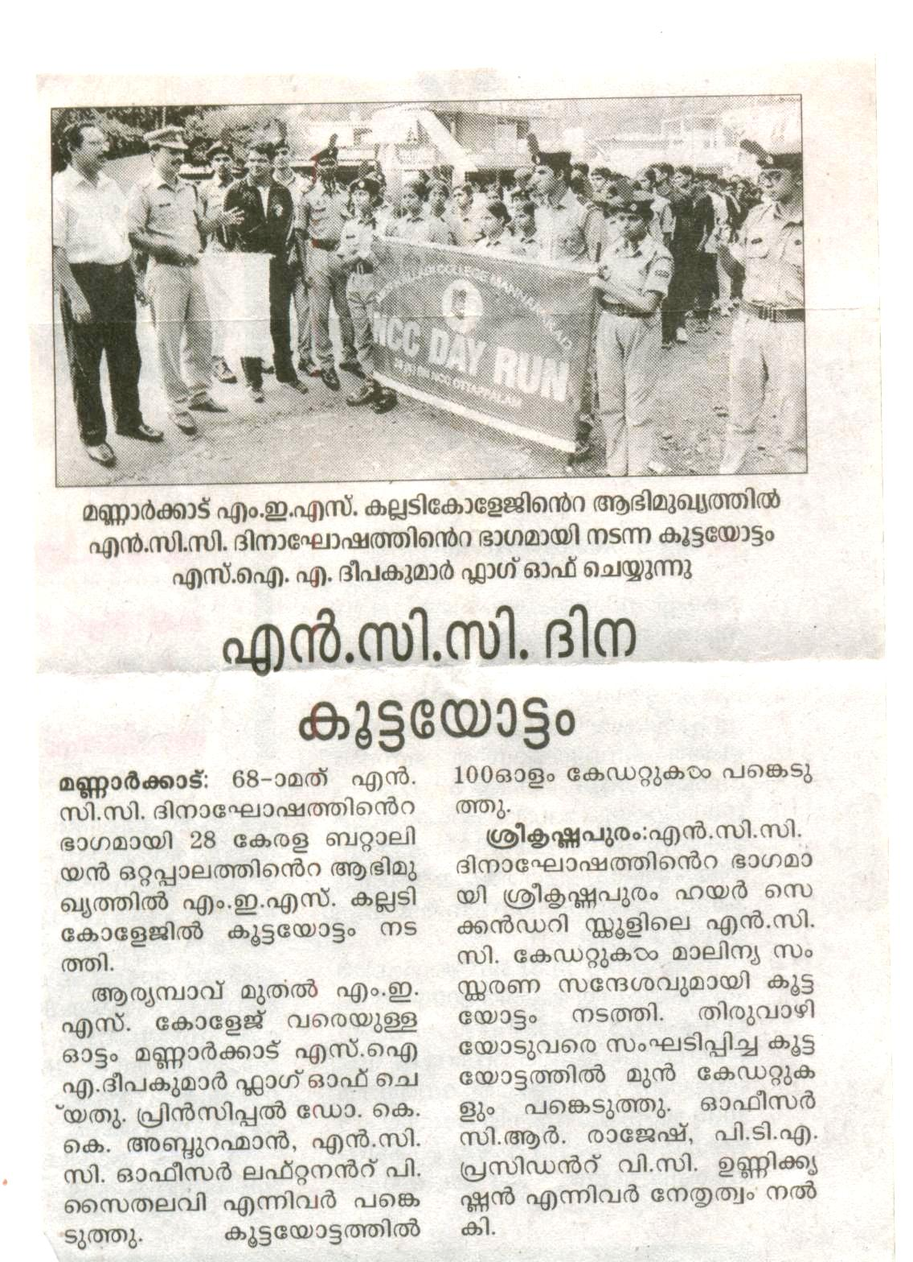
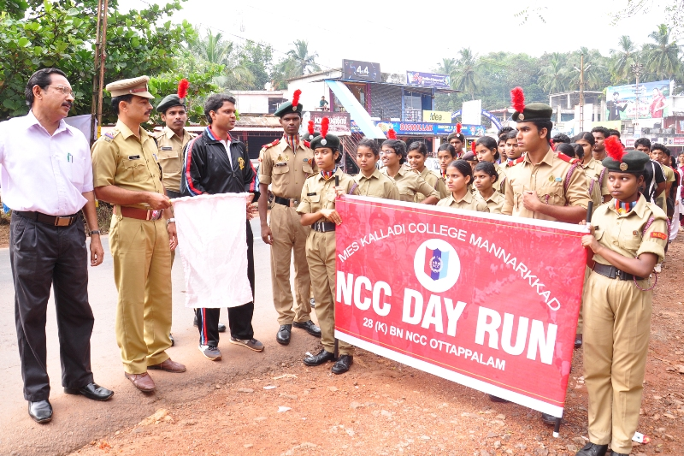

- Two days minicamp conducted in our college on 21 and 22 December 2013. In the camp other than the cadets of our college, cadets from three schools were participated.
- 18 parades were conducted in college on Saturdays from 9.00 hrs to 13.00 hrs.
- Silent Valley trekking conducted on 30 January 2014.
- A tour program to Kodaikanal conducted on 9th and 10th March 2014.

